Chapter 16, Problem 48.

Find v_{x}(s) in the circuit shown in Fig. 16.71.

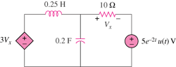

Figure 16.71
For Prob. 16.48.

